

Libyan international medical university

Faculty of information technology

Space Bus

Presenters

Mosab omaer 2802

Nehal kanoun 2778

***Introduction***

This website will propose a way for customers to buy bus tickets, make e-payment and select routes online, our mission to improve efficiency of bus ticket services and ensure customer satisfaction

***Problem* *Statement***

1- Passengers don’t have easy access to information about the bus route

2- Passengers is unaware of the bus arrival time

3- Passengers has no knowledge of the bus stops near by

***Objectives***

1. passengers will be able to book ticket online
2. Map for the passengers to know the routes and bus stops
3. allow passenger to pay with online payment methods
4. provide bus arrival time for the passengers

***Scope***

* System that organize bus routes
* Provide payment method to buy tickets
* Provide live location of the bus and available seats
* Search and selection of bus routes
* Customer support and feedback system

***Vision***

* Build IOS and android web application
* Add E-cards to the system
* Add option to cancel ticket in the app
* Give ability to users to sign up
* Create extra bus routes

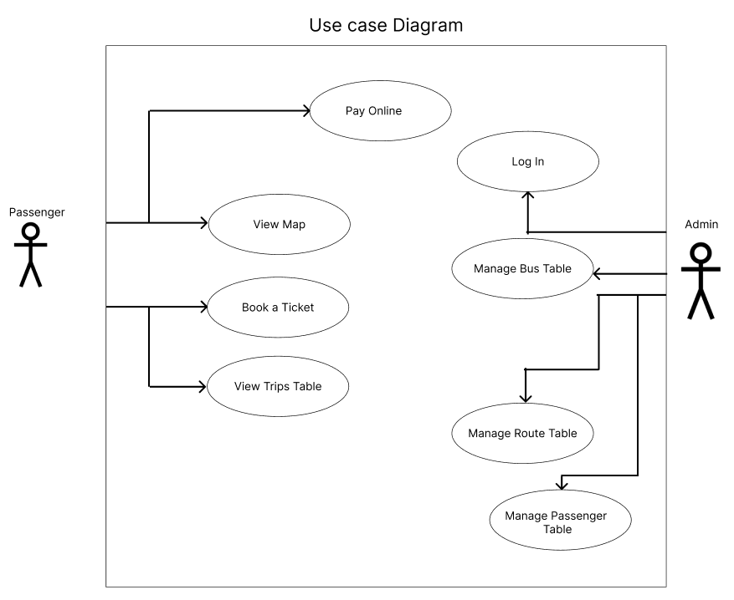

***Use case ID***

|  |  |
| --- | --- |
| UC1 | Login |
| UC2 | Manage bus table |
| UC3 | Manage route table |
| UC4 | Manage passenger table |
| UC5 | Pay online |
| UC6 | View map |
| UC7 | View trips table |
| UC8 | Book ticket |

***Use cases***

|  |  |
| --- | --- |
| Use case | Log in |
| Use case ID | UC1 |
| Actor | Admin |
| Description | The actor wants to Login into the system |
| Scenario | 1. Actors will click on the login button 2. Fill out the actor’s (username, password) 3. Click login |

|  |  |
| --- | --- |
| Use case | Manage bus table |
| Use case ID | UC 2 |
| Actor | admin |
| Description | The actor wants to manage bus table |
| scenario | 1. After logging in 2. Actor will click on bus table button 3. Edit or remove or add in the bus table |

|  |  |
| --- | --- |
| Use case | Manage route table |
| Use case ID | UC 3 |
| Actor | admin |
| Description | The actor wants to manage route table |
| scenario | 1. After logging in 2. Actor will click on route table button 3. Edit or remove or add in the route table |

|  |  |
| --- | --- |
| Use case | Manage passenger table |
| Use case ID | UC 4 |
| Actor | admin |
| Description | The actor wants to manage passenger table |
| scenario | 1. After logging in 2. Actor will click on passenger table button 3. add or remove in the passenger table |

|  |  |
| --- | --- |
| Use case | Pay online |
| Use case ID | UC 5 |
| Actor | passenger |
| Description | The actor wants to pay for the ticket |
| scenario | 1. after choosing routes 2. actor click on pay button 3. actor fill in phone number 4. click on proceed button 5. fill in verification code 6. click on pay button |

|  |  |
| --- | --- |
| Use case | View map |
| Use case ID | UC6 |
| Actor | passenger |
| Description | The actor wants to view map |
| Scenario | 1. After entering website 2. In the actor’s dashboard the map will displays |

|  |  |
| --- | --- |
| Use case | View Trips Table |
| Use case ID | UC7 |
| Actor | passenger |
| Description | The actor wants to view Trip Table |
| Scenario | 1. After entering website 2. In the actor’s dashboard the Trip Table will load and be displayed |

|  |  |
| --- | --- |
| Use case | Book Ticket |
| Use case ID | UC8 |
| Actor | passenger |
| Description | The actor wants to Book Bus Ticket |
| Scenario | 1. After entering website 2. Click on Book Ticket Button 3. Choose (From/To) Destination 4. Fill in Number of Tickets and Email address 5. After filling in the price and Bus ID, time will be displayed |

***Functional requirement***

|  |  |  |
| --- | --- | --- |
| Function ID | Use case ID | Description |
| F1 | UC1 | The system shall allow the actor to log in to the system by filling out the username and password text boxes |
| F2 | UC1 | the system shall display error message if the password is incorrect |
| F3 | UC1 | The system shall display the actor’s dashboard after logging in |
| F4 | UC2 | The system shall display a list of buses with their details |
| F5 | UC2 | The system shall allow actor to add, edit, delete bus table cells |
| F6 | UC2 | The system shall display check box button of each bus to delete multiple buses |
| F7 | UC2 | The system shall display edit window when actor choose bus and click on edit button where it contains From, To, Number of passengers, Arrival Time, Departure Time, Driver Name, Phone number Text boxes |
| F8 | UC2 | The system shall display Add Bus window when actor click on add button where system will display ID, From, To, Number of passengers, Driver Name, Phone number Text boxes |
| F9 | UC2 | The system shall allow actor to click on add button |
| F10 | UC2 | the system must display message box confirming the operation after any change |
| F11 | UC2 | The system shall provide a search functionality to find buses based on specific criteria (bus ID). |
| F12 | UC3 | The system shall display a list of routes with their details |
| F13 | UC3 | The system shall display check box button of each route to delete multiple routes |
| F14 | UC3 | The system shall display edit window when actor choose route and click on edit button where it contains Station Name Text boxes and select Previous/Next station from drop down list |
| F15 | UC3 | The system shall display Add route window when actor click on add button where system will display Station Name Text boxes and select Previous/Next station from drop down list |
| F16 | UC3 | The system shall allow actor to click on add button |
| F17 | UC3 | the system must display message box confirming the operation after any change |
| F18 | UC3 | The system shall provide a search functionality to find routes based on specific criteria (station name). |
| F19 | UC4 | The system shall display a list of Passengers with their details |
| F20 | UC4 | The system shall display check box button of each Passenger to delete multiple Passenger |
| F21 | UC4 | The system shall display Add Passenger window when actor click on add button where system will display passenger email ,phone number, number of tickets, tickets, price |
| F22 | UC4 | The system shall allow actor to click on add button |
| F23 | UC4 | the system must display message box confirming the operation after any change |
| F24 | UC4 | The system shall provide a search functionality to find passengers based on specific criteria. |
| F25 | UC5 | The system shall display phone number text box |
| F26 | UC5 | The system shall display proceed button |
| F27 | UC5 | The system shall unlock verification text box |
| F28 | UC5 | The system shall display pay button |
| F29 | UC6 | The system shall display a map interface to the actor. |
| F30 | UC6 | The system shall provide zoom and pan functionality to navigate the map. |
| F31 | UC6 | The system shall display markers or labels to indicate important locations (e.g., bus stops). |
| F32 | UC7 | The system shall show the details of each trip, including the bus ID , from , To ,arrival time |
| F33 | UC8 | The system shall display drop down list of (from , to)destinations and( email address and number of passengers) text box |
| F34 | UC8 | The system shall display price and departure time after filling in all data |
| F35 | UC8 | The system shall update the passenger and bus table with the booked seat information. |